Terraform -02

LIFE CYCLES:

create_before_destroy

What it does
- Creates new resource first
- Destroys old resource later
- Avoids downtime

Default behavior
Terraform normally does:
Destroy old → Create new
With create_before_destroy:
Create new → Destroy old

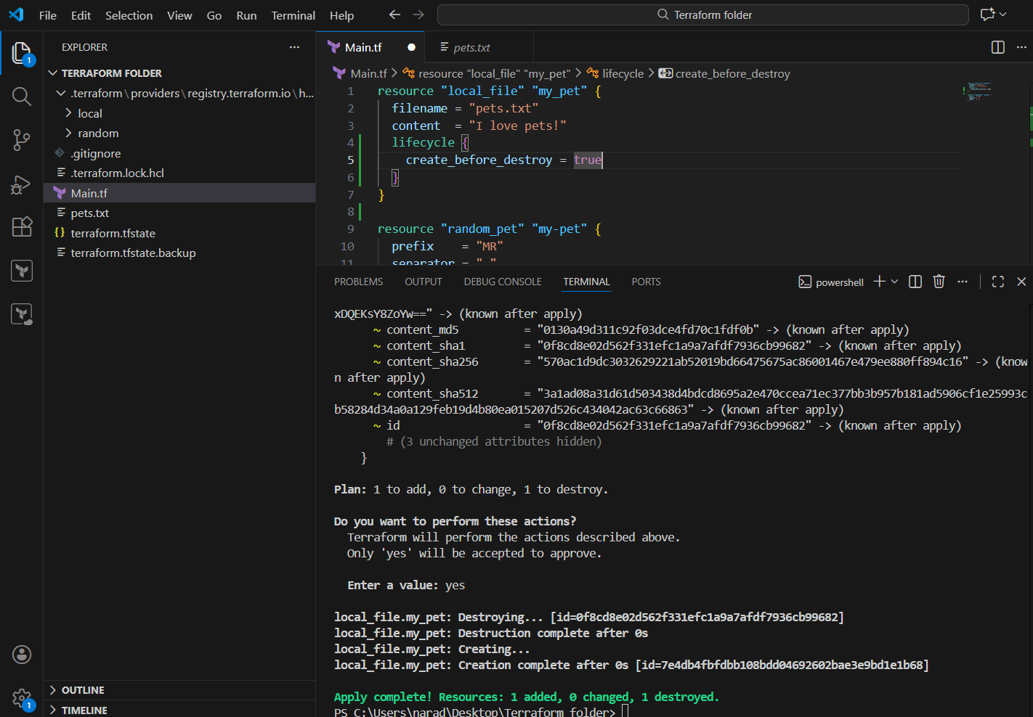
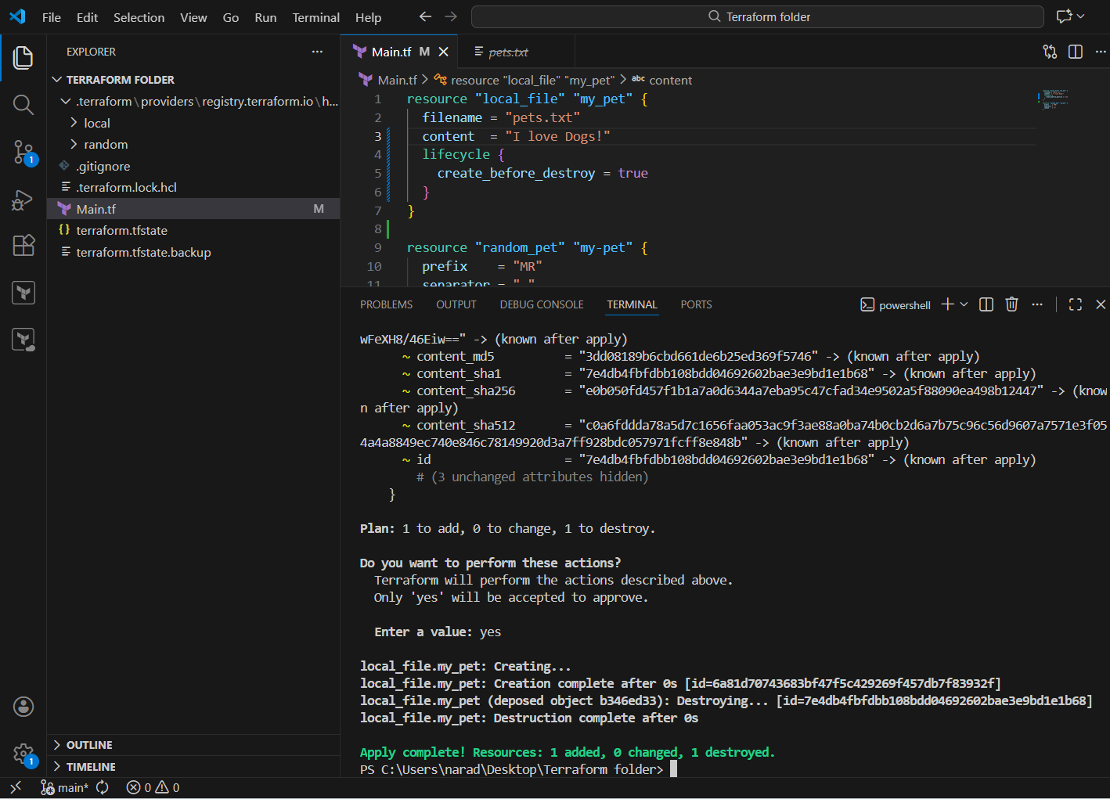

If we want to prevent the existing Infrastructure we can use {prevent_destroy = true} lifecycle.

prevent_destroy

What it does
- Blocks Terraform from destroying the resource
- Even if you run terraform destroy

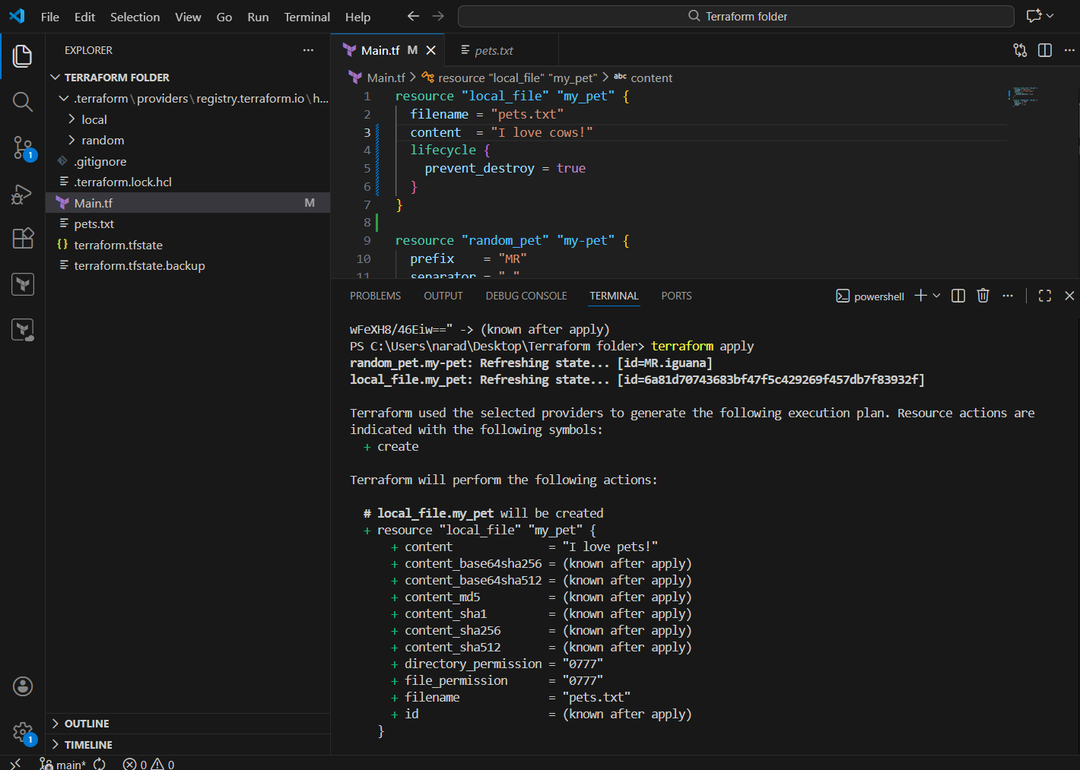
Again if we enter terraform apply because of this lifecycle it wont get deleted
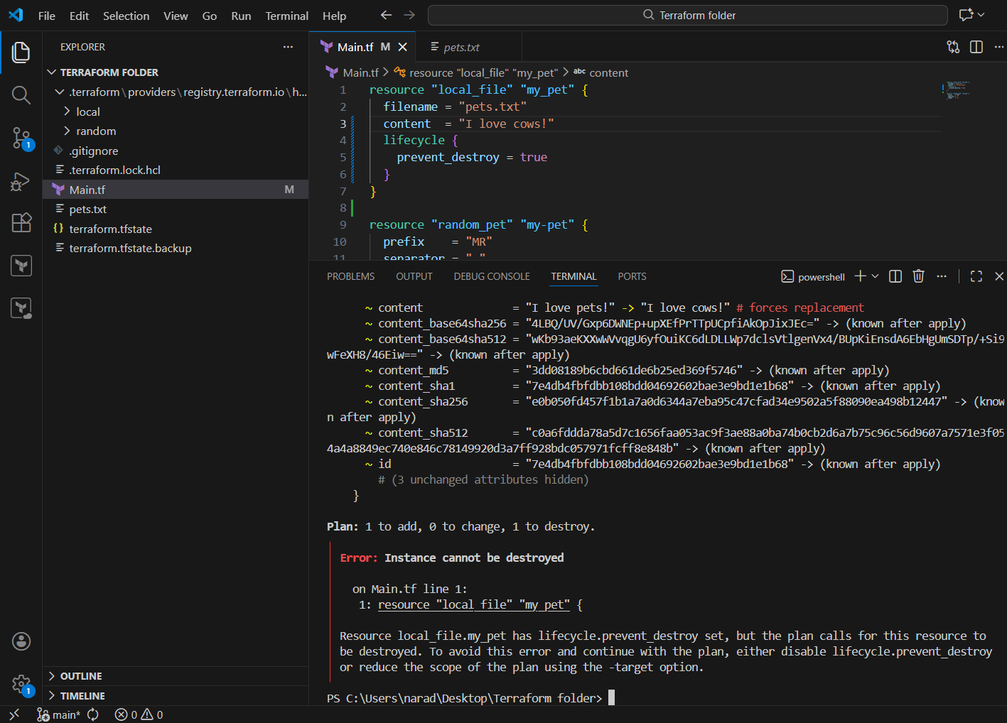

ignore_changes

What it does
- Tells Terraform to ignore specific attribute changes
- Terraform will not detect drift for those fields

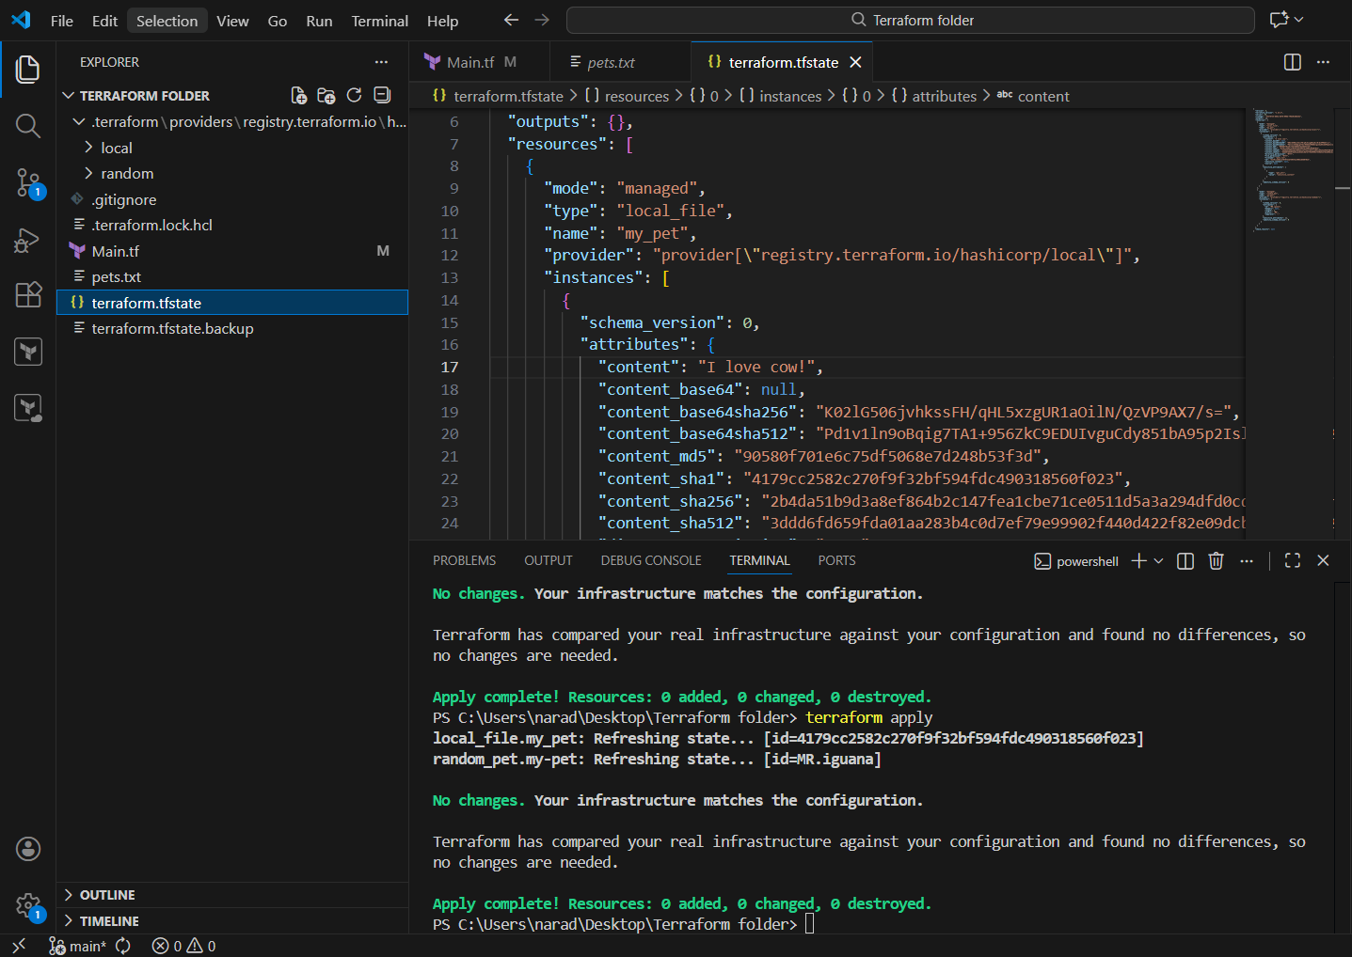
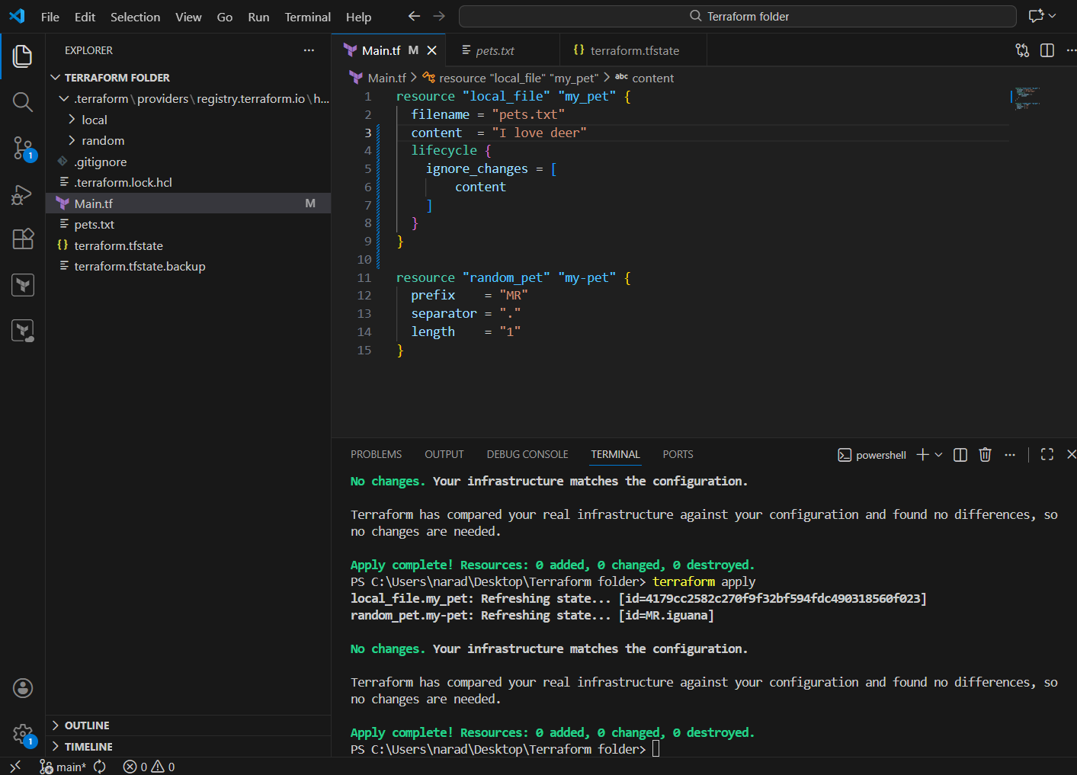

resource block
Used to create something using Terraform.

In your code:
resource "random_pet" "my-pet" { }
resource "local_file" "my-pet" { }
Meaning:
- resource → tells Terraform to manage something
- "random_pet" / "local_file" → resource type
- "my-pet" → resource name (your reference name)
You refer to them as:
random_pet.my-pet
local_file.my-pet

2️⃣ random_pet resource
Generates a random name (used for testing, learning).
resource "random_pet" "my-pet" {
prefix = var.prefix
separator = "-"
length = var.length
}

What each attribute does:
- prefix → text added at the beginning
Example: MR-helping-pup
- separator → symbol between words (-)
- length → number of random words

3️⃣ local_file resource
Creates a file on your local machine.
resource "local_file" "my-pet" {
filename = var.filename
content = var.content
}

Attributes:
- filename → name/path of the file to be created
- content → text written inside the file

variable block
Used to make your code dynamic and reusable.
variable "filename" {
type = string
}
Meaning:
- variable → declares an input value
- "filename" → variable name
- type = string → accepts only text

default value
Provides a value automatically if nothing is passed.
variable "content" {
default = "I love dog"
type = string
}
Meaning:
- If you don’t pass a value → Terraform uses default
- Makes execution simple

type
Defines what kind of value is allowed.
From your code:
type = string
type = number
- string → text ("hello")
- number → numeric value (2)

var.<name> usage
Used to read variable values.
filename = var.filename
length = var.length
Meaning:
- var. → access variable
- var.length → value of variable "length"

terraform.tfstate
Automatically created file.
Purpose:
- Stores current infrastructure state
- Terraform uses it to know what exists
⚠️ Never edit manually

9️⃣ terraform.lock.hcl
Created during terraform init.
Purpose:
- Locks provider versions
- Ensures same behavior across systems

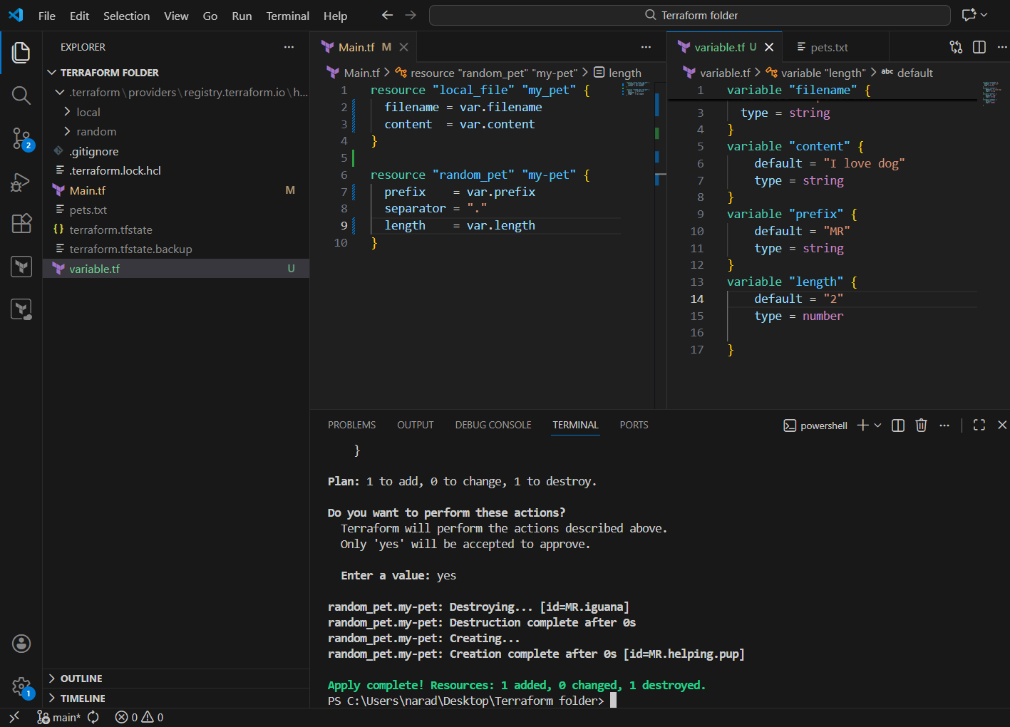
Default changed from 2 to 1 so now only one name in output
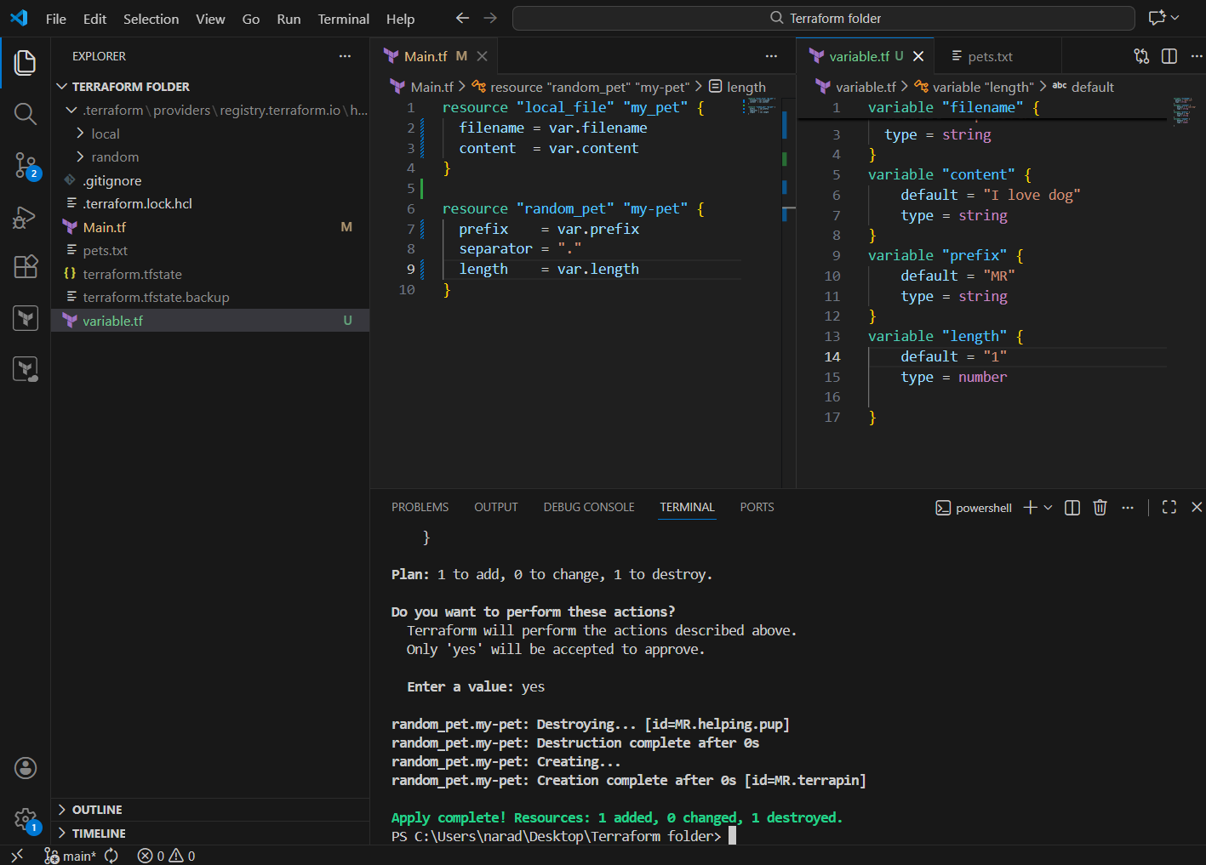
Integrate Terraform in Jenkins using the Terraform plugin.

Title
Integrating Terraform with Jenkins Using Terraform Plugin

Objective
To automate the provisioning of AWS infrastructure by integrating Terraform with Jenkins using the Terraform plugin and executing Terraform commands through Jenkins jobs.

Prerequisites
- Jenkins installed and running
- Terraform plugin installed in Jenkins
- AWS account with access keys
- GitHub repository containing Terraform files
- Git plugin installed in Jenkins

STEP 1️⃣ Install Required Jenkins Plugins
Go to:
Manage Jenkins → Plugins → Available
Install:
- Terraform
- Git
- Aws credentials

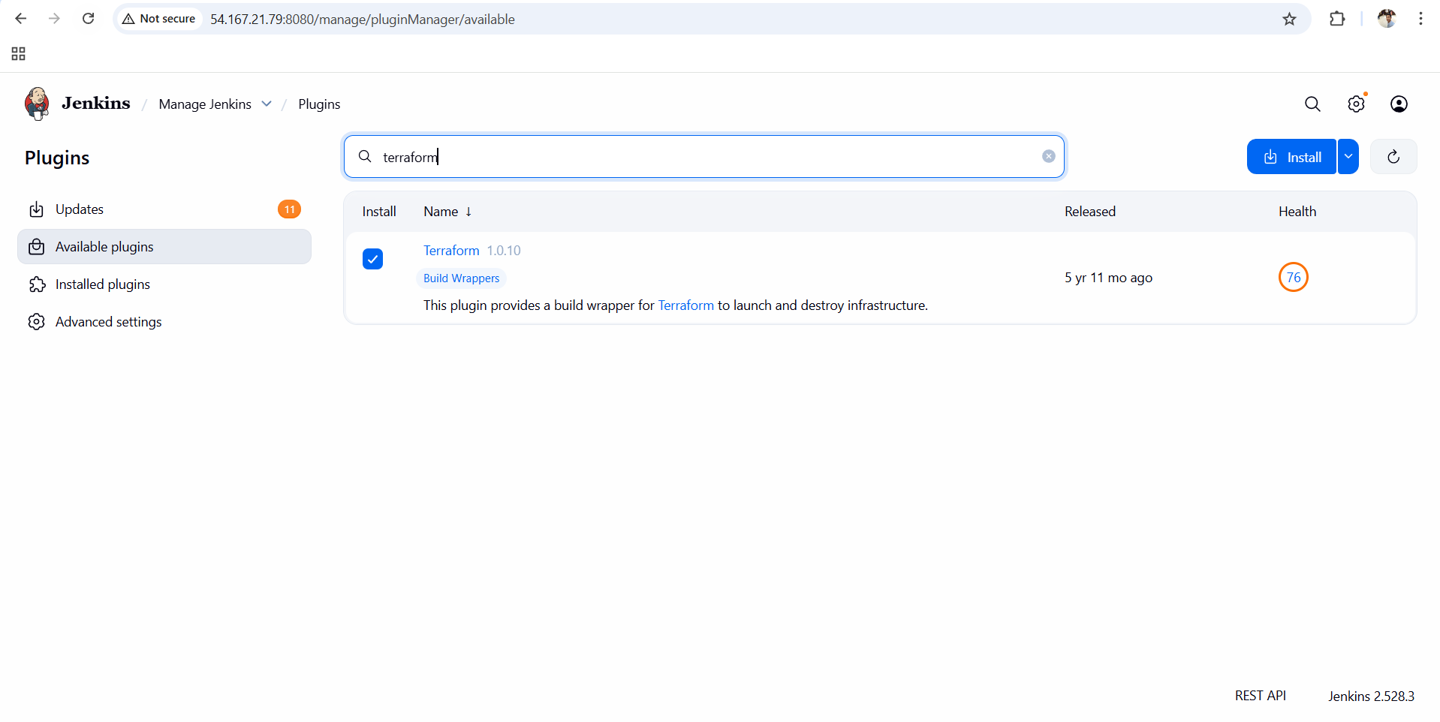

STEP 2️⃣ Configure Terraform in Jenkins (Global Tool)
Go to:
Manage Jenkins → Tools
Scroll to Terraform section:
- Click Add Terraform
- Name:
- terraform
- ✔ Check Install automatically
- Version: choose latest stable (example: 1.6.x)

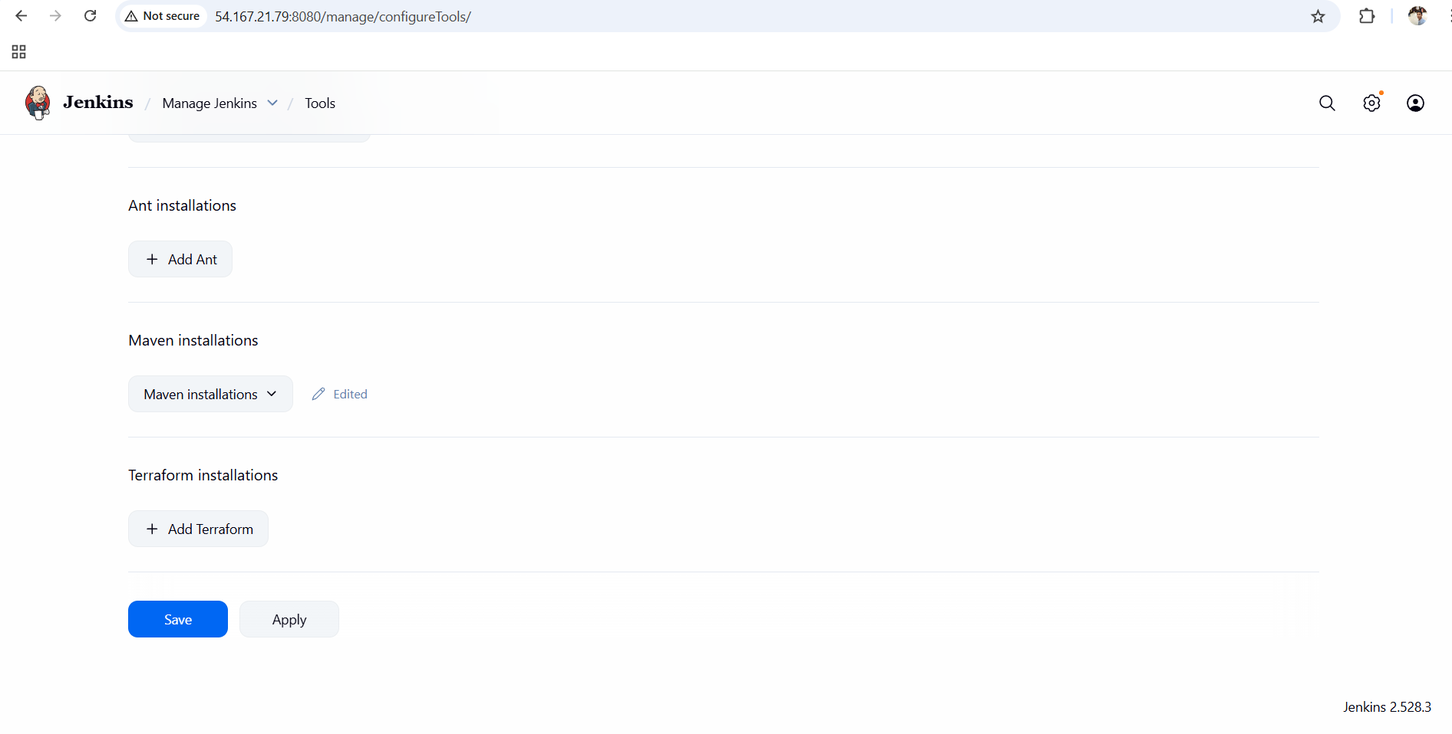
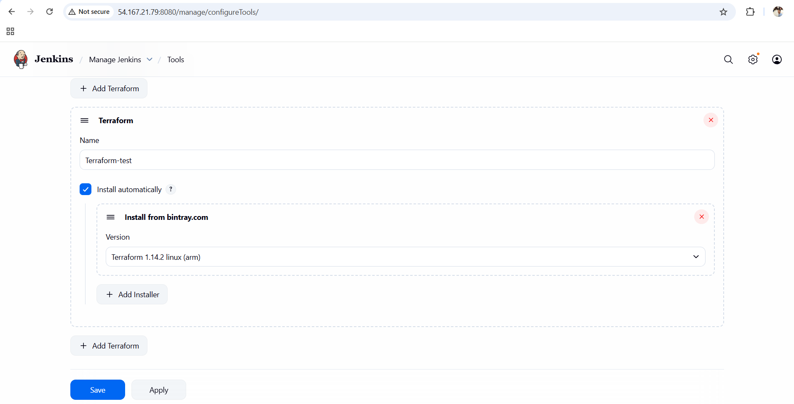

STEP 3️⃣ Add AWS Credentials in Jenkins
Go to:
Manage Jenkins → Credentials → (global) → Add Credentials

Select:
- Kind: AWS Credentials

Fill:
- ID:
- aws-creds
- Access Key ID: <your_aws_access_key>
- Secret Access Key: <your_aws_secret_key>

THESE CREDENTIALS HAS TO BE TAKE FROM AWS IAM

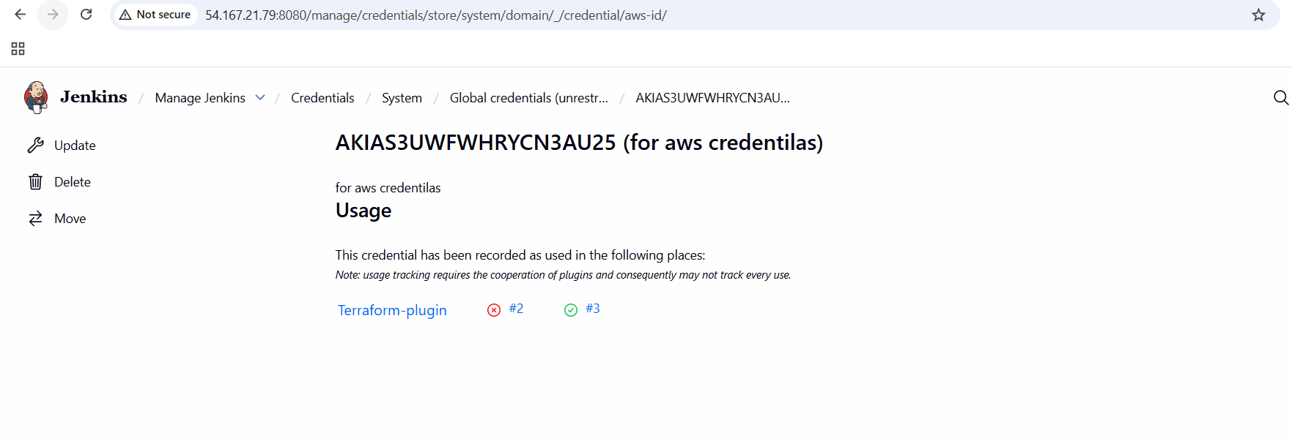
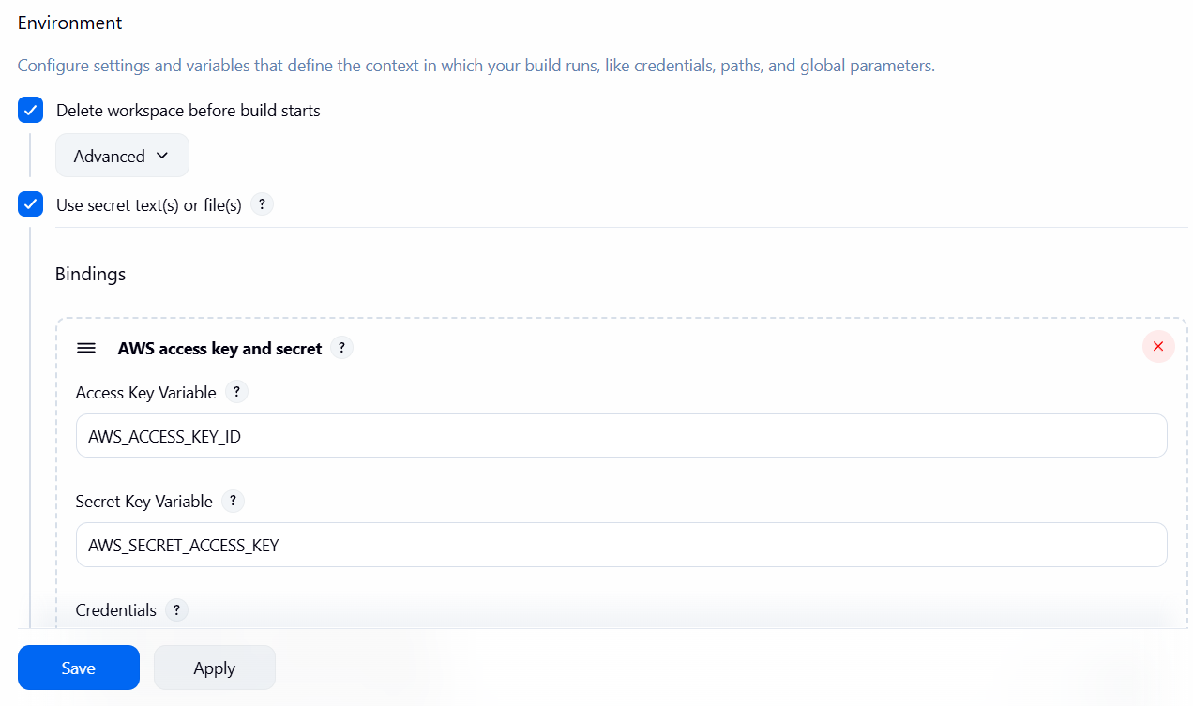

STEP 4️⃣ Create Jenkins Job
Go to Jenkins Dashboard:
New Item
- Job Name:
- terraform-job
- Select:
✅ Freestyle project
- Click OK

STEP 5️⃣ Connect GitHub Repository
Inside job configuration:

Source Code Management
- Select: Git
- Repository URL:
- https://github.com/<username>/<repo>.git
- Branch:
*/main

Add these commands in Build steps

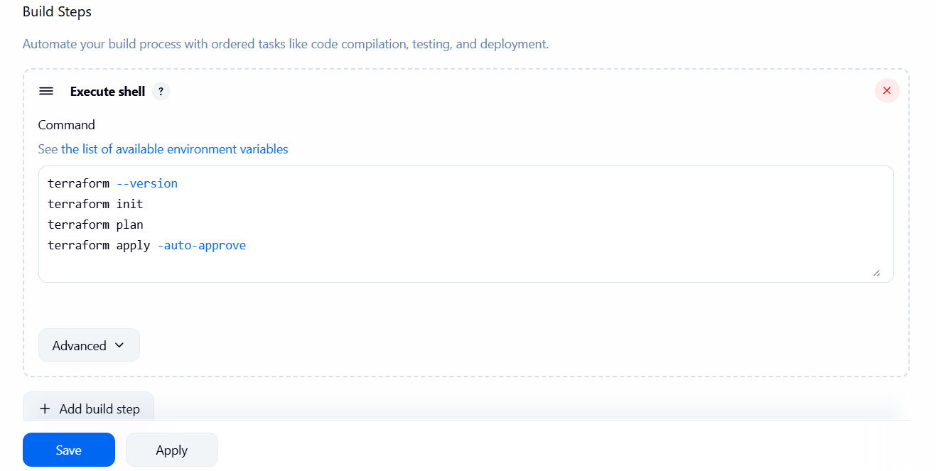

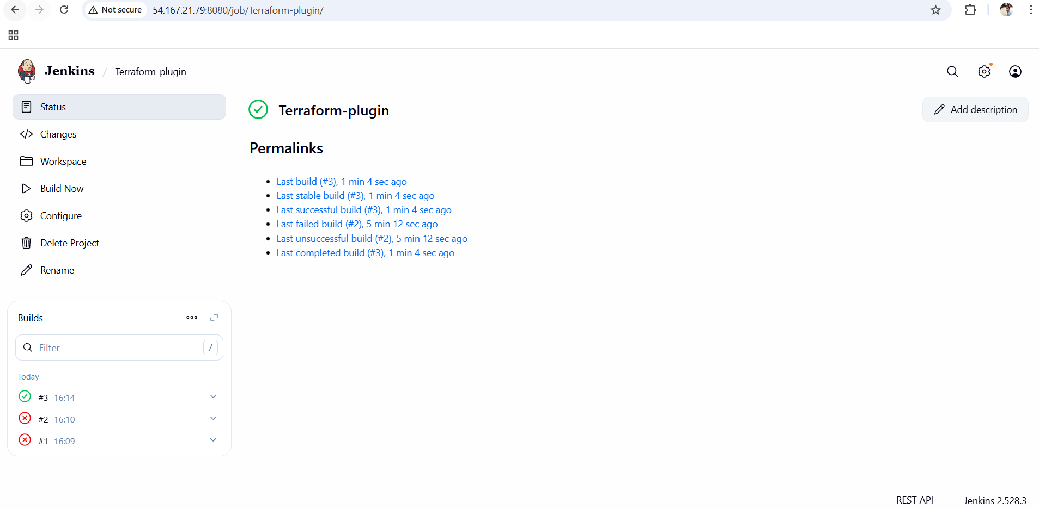

Conclusion
Terraform was successfully integrated with Jenkins using the Terraform plugin. Jenkins now automates Terraform workflows such as init, plan, and apply, enabling consistent, repeatable, and automated infrastructure provisioning through CI/CD pipelines.

